**Lab-2**: Basic Linux Commands

**Objectives:**

The objective of this lab is to introduce and familiarize users with a variety of basic Linux commands essential for system management and information retrieval. By exploring commands that provide CPU, hardware, and memory details, users will gain insights into system architecture and configuration. Additional commands focusing on disk usage, partition management, and shutdown procedures help users manage and maintain their system effectively. Networking commands included in this lab aim to enhance users' ability to monitor and troubleshoot network connections. Finally, commands related to package management and system updates are covered to ensure users can keep their systems up-to-date and manage software installations efficiently.

**1. Command: lscpu**

Interpretation: It is used to display information about the CPU architecture

**Output:**

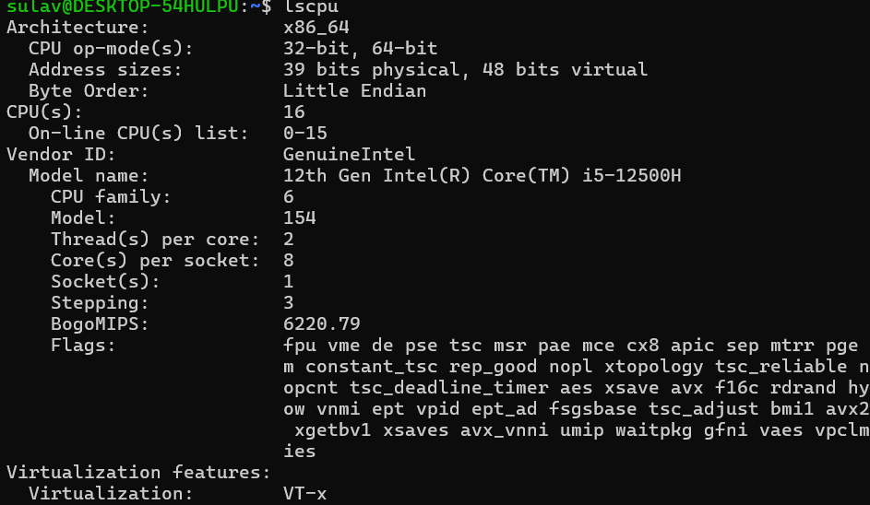

**2. Command: lshw**

Interpretation: It is used to extract detailed information on the hardware configuration of the machine.

**Output:**

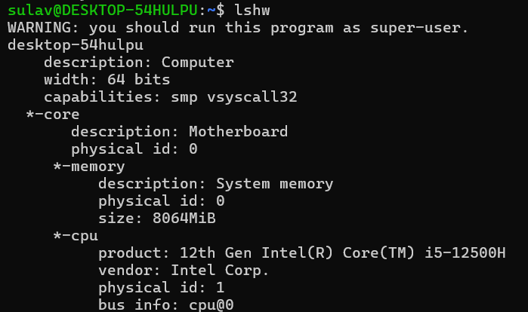

**3. Command: sudo lshw**

Interpretation: It is used to extract detailed information on the hardware configuration of the machine.

**Output:**

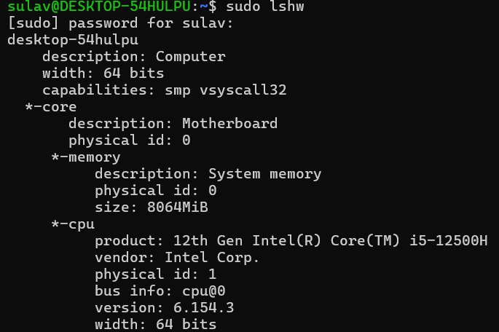

**4. Command: hwinfo**

Interpretation: hwinfo is used to probe for the hardware present in the system. It can be used to generate a system overview log which can be later used for support.

**Output:**

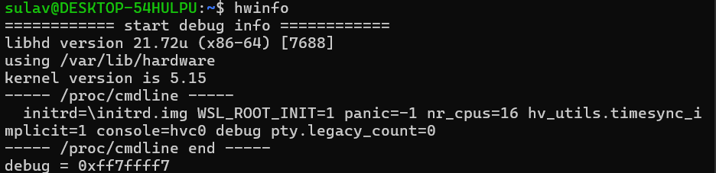

**5. Command: hwinfo --short**

Interpretation: It shows only a quick summary of hardware present in the system.

**Output:**

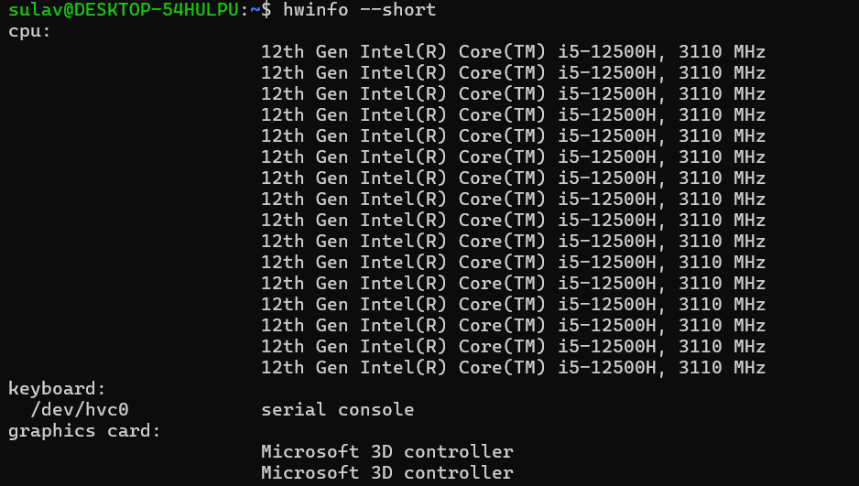

**6. Command: lspci**

Interpretation: It is used to displays information about PCI buses in the system and devices connected to them.

**Output:**

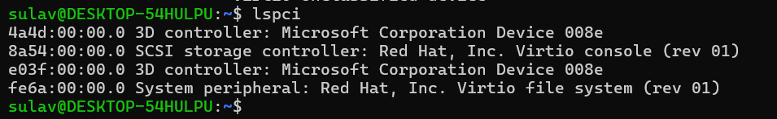

**7. Command: lsscsi**

Interpretation: It is used to list SCSI devices (or hosts) currently attached to the system.

**Output:**

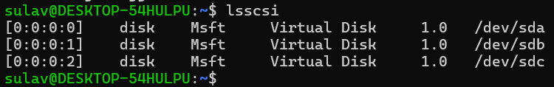**8. Command: lsusb**

Interpretation: It displays information about USB buses in the system and the devices connected to them. It uses udev’s hardware database to associate a full human-readable name to the vendor ID and the product ID.

**Output:**

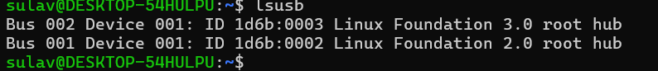

**9. Command: inxi**

Interpretation: Command line system information script for console and IRC.

**Output:**

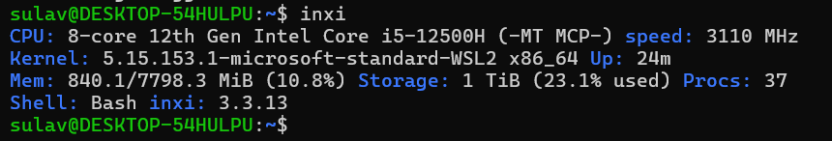

**10. Command: inxi -fx**

Interpretation: Show all CPU flags used, not just the short list.

**Output:**

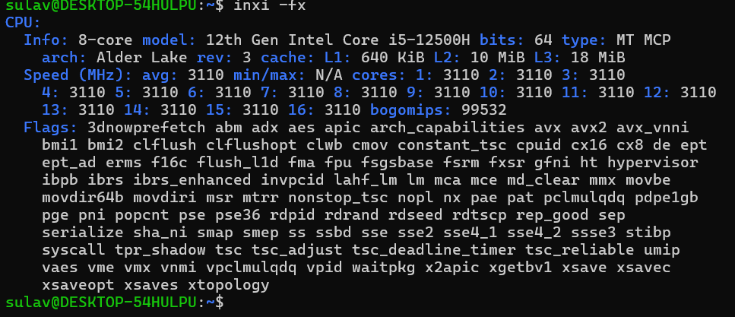

**11. Command: inxi –Fx**

**Output:**

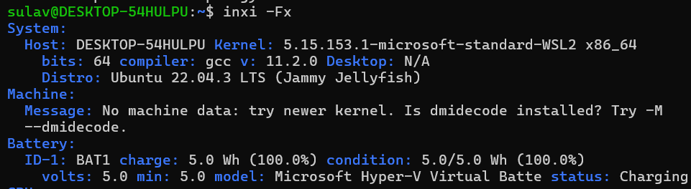

**12. Command: lsblk**

Interpretation: lists information about all available or the specified block devices.

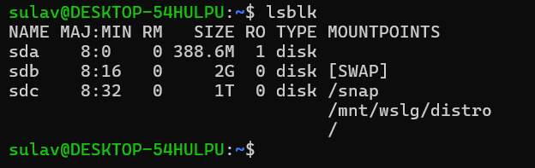**Output:**

**13. Command: df**

Interpretation: It displays the amount of space available on the file system containing each file name argument. If no file name is given, the space available on all currently mounted file systems is shown.

**Output:**

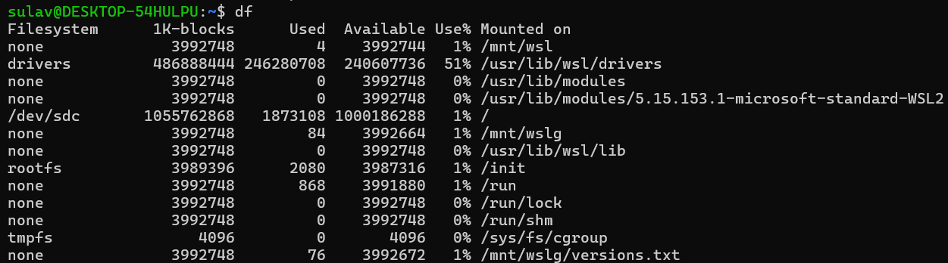

**14. Command: pydf**

Interpretation: python script that displays the amount of disk space available on the mounted file systems, using different colors for different types of file systems.

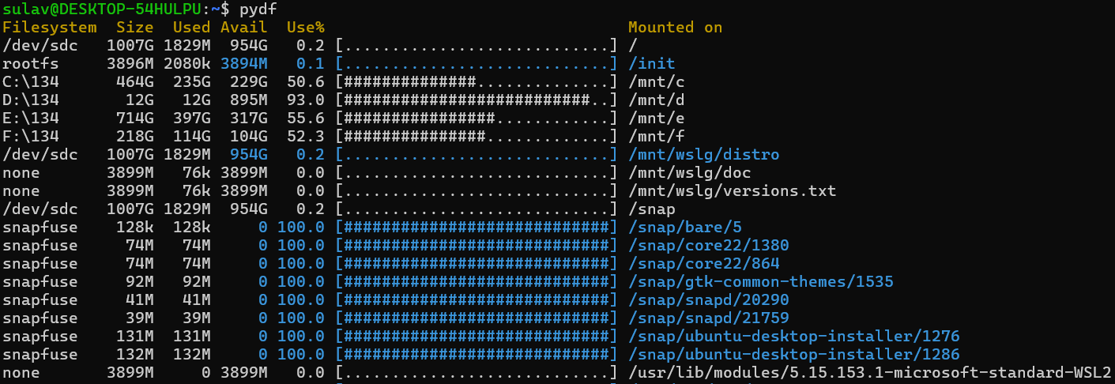

**15. Command: fdisk**

Interpretation: dialog-driven program for creation and manipulation of partition tables. It understands GPT, MBR, Sun, SGI and BSD partition tables.

**16. Command: fdisk -l**

Interpretation: It lists the partition tables for the specified devices.

**Output:**

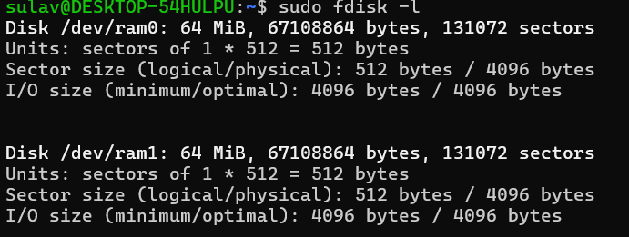

**17. Command: free**

Interpretation: Display amount of free and used memory in the system.

**Output:18. Command:** **dmidecode -t processor**

Interpretation: dumps the computers DMI (some say SMBIOS) table contents in a human-readable format and -r processor allows to dump the processor’s information

**Output:**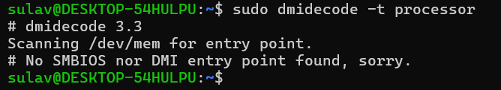

**19. Command: dmidecode -t memory**

Interpretation: -t memory allows to dump the memory devices information’s.

**Output:**

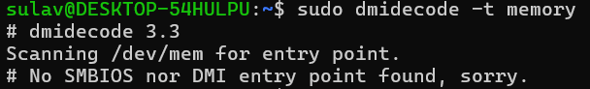

**20. Command: dmidecode -t bios**

Interpretation: -t bios allows to dump the BIOS Information

**Output:**

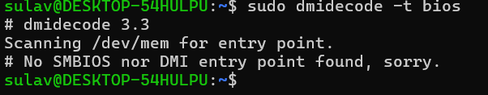

**21. Command: cat /proc/cpuinfo**

Interpretation: read the file /proc/cpuinfo to output the processor’s information like CPU family, model, microcode, flags, address sizes, cache_allignments,etc.

**Output:**

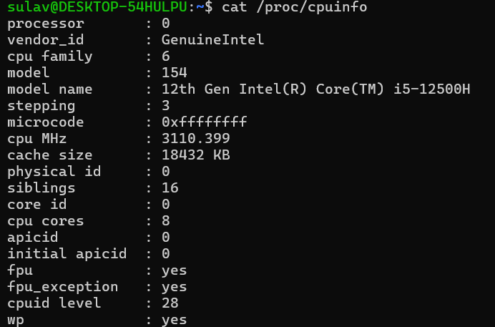

**22. Command: cat /proc/meminfo**

Interpretation: reads file /proc/meminfo and output the various information of memory segments of the computer system.

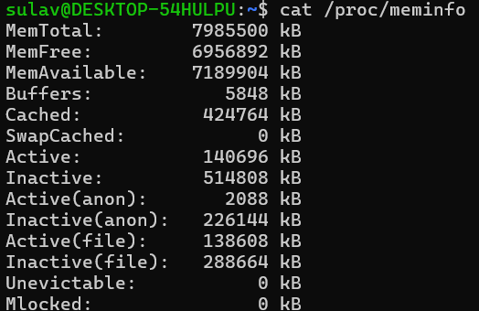**Output:**

**23. Command: cat/proc/version**

Interpretation: It displays the system information in quick summary.

**Output:**



**24. Command: hdparm -i /dev/sda**

Interpretation: It provides a command line interface to various kernel interfaces supported by the Linux SATA/PATA/SAS ”libata” subsystem and the older IDE driver subsystem

**Output:**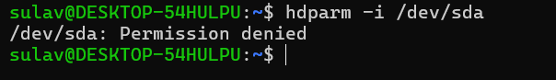

**25. Command: uname**

Interpretation: It prints the system information.

**Output:**

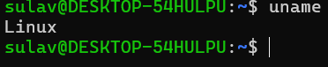

**26. Command: uname -n**

Interpretation: It prints the network node hostname.

Output:

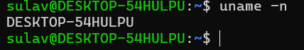

**27. Command: uname -v**

Interpretation: It print the kernel version.

Output:

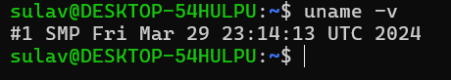

**28. Command: uname -r**

Interpretation: It print the kernel release.

**Output:**



**29. Command: uname -m**

Interpretation: It is used to print the machine hardware name.

Output:

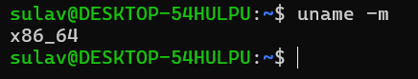

**30. Command: uname -a**

Interpretation: It print all informations like kernel name,network node hostname, kernel release and version,machine hardware name, processor type,etc.

**Output:**



**31. Command: sudo lshw –html>lshw.html**

Interpretation: lshw command is used to generate the detailed information of the systems hardware configuration from various files in the /proc directory and is saved in lshw.html

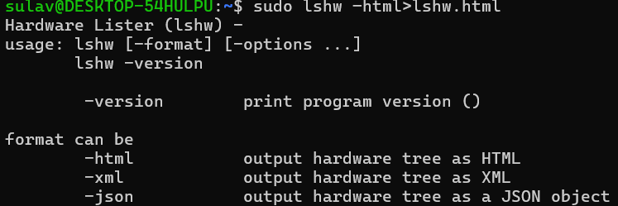**Output:**

**32. Command: factor 1203343**

Interpretation: It print the prime factors of the given numbers, either given from command line or read from standard input

**Output:**

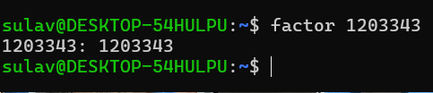

**33. Command: echo ‘3*9’| bc**

**Interpretation:** echo displays the string passed and ‘|’ symbol is used to redirect the output of echo to arbitrary precision calculator language bc to produce the product of 3 and 9.

**Output:**

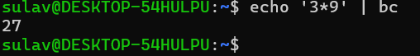

**34. Command: echo ‘(6*5)-8’| bc**

Interpretation: It calculates the give expression and displays in the terminal

**Output:**

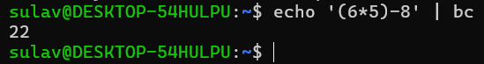

**35. Command: id**

Interpretation: It print real and effective user and group IDs.

**Output:**



**36. Command: lsusb | tee lsusb.txt**

Interpretation: lsusb outputs all the usb devices and ‘|’ symbol redirects the output of lsusb into file lsusb.txt

**Output:**

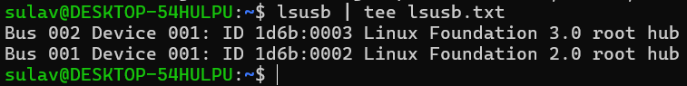

**37. Command: cat lsusb.txt**

Interpretation: It reads the file lsusb.txt

**Output:**

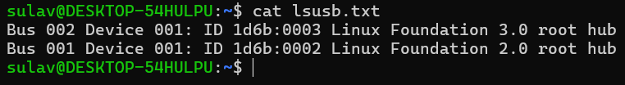

**38. Command: shutdown**

Interpretation: It schedules the shutdown of the system after one minute.

**Output:**



**39. Command: shutdown now**

Interpretation: power-off the machine instantly

**Output:**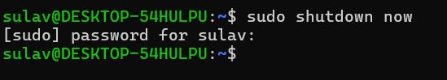

**40. Command: shutdown 13:20**

Interpretation: This command shuts down the machine at 13:20.

Output:

**41. Command: shutdown 10**

Interpretation: It schedules the shutdown of the system after ten minutes

**Output:**

**42. Command: shutdown -r +10**

Interpretation: schedule the shutdown of the system after ten minutes



**43. Command: shutdown -c**

Interpretation: Cancel a pending or scheduled shutdown.

**Output:**



**44. Command: ping -w 3 google.com**

Interpretation: send ICMP ECHO_REQUEST to google.com

**Output:**

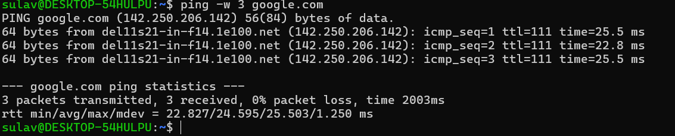

**45. Command: netstat**

Interpretation: Print network connections, routing tables, interface statistics, masquerade connections, and multicast memberships

**Output:**

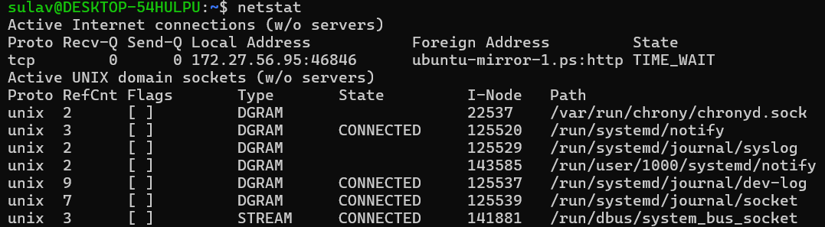

**46. Command: netstat -r**

Interpretation: Display the kernel routing tables.

**Output:**

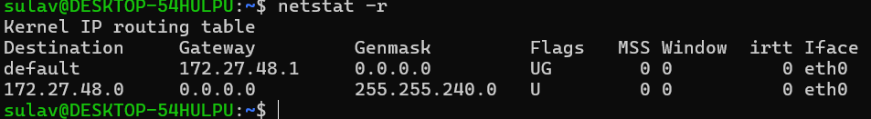

**47. Command: netstat -p**

Interpretation: Show the PID and name of the program to which each socket belongs. A hyphen is shown if the socket belongs to the kernel (e.g. a kernel service, or the process has exited but the socket hasn’t finished closing yet).

**Output:**

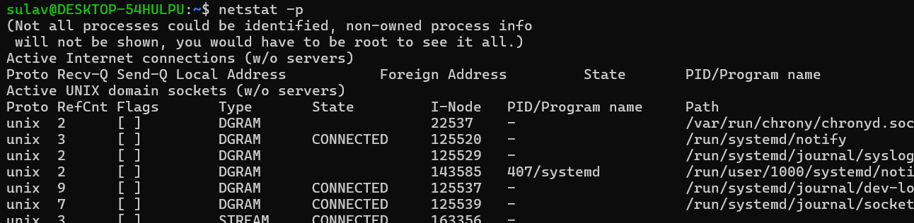

**48. Command: sudo tcpdump**

Interpretation: It prints out a description of the contents of packets on a network interface

**Output:**

**49. Command: host google.com**

Interpretation: performs DNS lookups. It is normally used to convert names to IP addresses and vice versa.

**Output:**

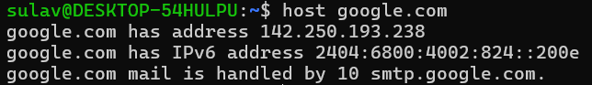**50. Command: tracepath achsnepal.edu.np**

Interpretation: traces path to a network host discovering MTU along this path.

Output:

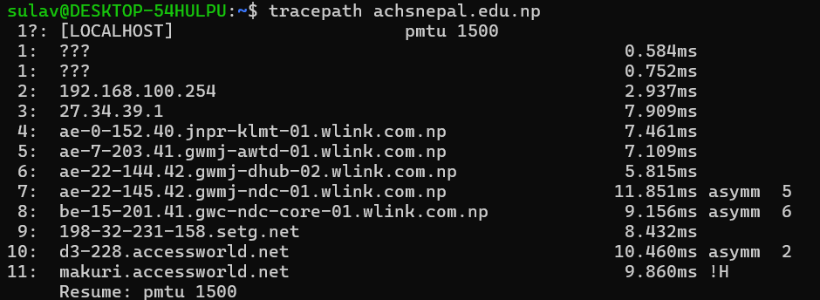

**51. Command: ifconfig**

Interpretation: It displays the status of the currently active interfaces..

**Output:**

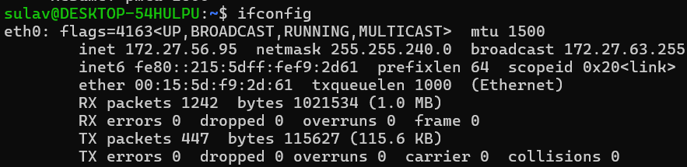

**52. Command: route**

Interpretation: show / manipulate the IP routing table

**Output:**

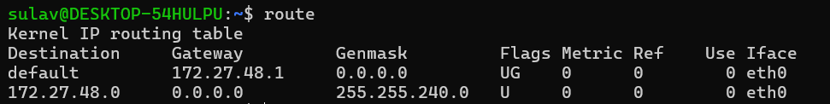

**53. Command: nslookup achsnepal.edu.np**

Interpretation: query Internet domain name servers interactively

**Output:**

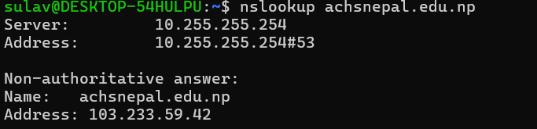

**54. Command: whois brainyquote.com**

Interpretation: guess the right server to ask for the specified object. If no guess can be made it will connect to whois.networksolutions.com for NIC handles or whois.arin.net for IPv4 addresses and network names.

**Output:**

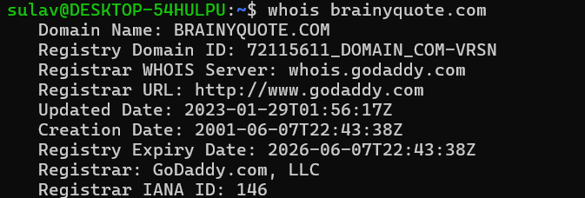

**55. Command: sudo apt-get update**

Interpretation: resynchronize the package index files from their sources.

Output:

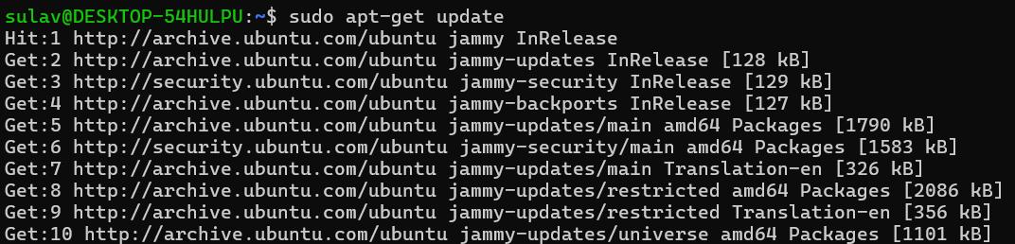

**56. Command: sudo apt-get upgrade**

Interpretation: install the newest versions of all packages currently installed on the system from the sources enumerated in /etc/apt/sources.list

**Output:**

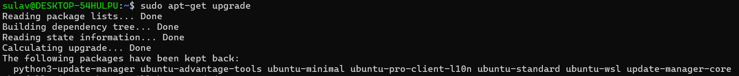

**57. Command: sudo apt-get install sl**

Interpretation: install package sl

**Output:**

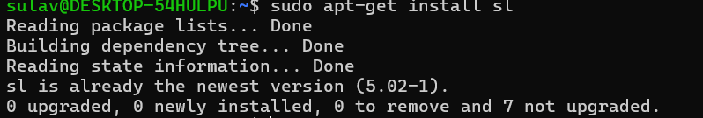

**58. Command: sl**

Interpretation: display animations aimed to correct users who accidentally enter sl instead of ls

**Output:**

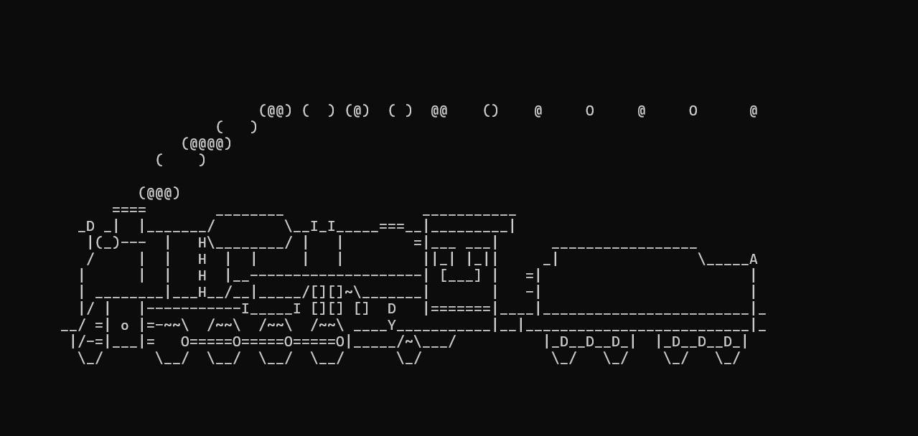

**59. Command: sudo -s**

Interpretation: Run the shell specified by the SHELL environment variable if it is set or the shell specified by the invoking user’s password database entry.

**Output:**

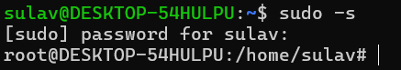

**60. Command: exit**

Interpretation: exit the current program

**Output:**



**Conclusion:**

The objective of this lab is to introduce and familiarize users with a variety of basic Linux commands essential for system management and information retrieval. By exploring commands that provide CPU, hardware, and memory details, users will gain insights into system architecture and configuration. Additional commands focusing on disk usage, partition management, and shutdown procedures help users manage and maintain their system effectively. Networking commands included in this lab aim to enhance users' ability to monitor and troubleshoot network connections. Finally, commands related to package management and system updates are covered to ensure users can keep their systems up-to-date and manage software installations efficiently.